|  |
| --- |
| Matthew’s Games |
| WIP TITLE |
| **RPG Platformer** |
| Version #0.1  All work Copyright © 2020 by Matthew’s Games.  All rights reserved. |
| **Matthew Pereira** |
|  |

**Matthew’s Games**

|  |
| --- |
| November 20th 2020 |

**Table of Contents**

[Your Table of Contents should go here. Make sure that your document’s sections are hyperlinked to their corresponding pages.]

**Version History**

Version: 0.1: Initial Release

1. **Game Overview**

*This game is just a normal platformer with some rpg elements, such as fighting enemies while traversing over obstacles and jump*

1. **Game Play Mechanics**

*As the player character your goal is to run around to map and find the exit to the next stage, and progress on, and kill enemies to collect more points*

1. **Camera**

*The camera is in a Frontal 2d view of the game.*

1. **Controls**

*The Game uses touch screen to move around and do actions. Such as a joystick to control movement, and buttons to attack and jump.*

1. **Saving and Loading**

*There is no saving feature planned for the game, as it is an arcade type game, the only thing that will be saved is probably high scores.*

1. **Interface Sketch**

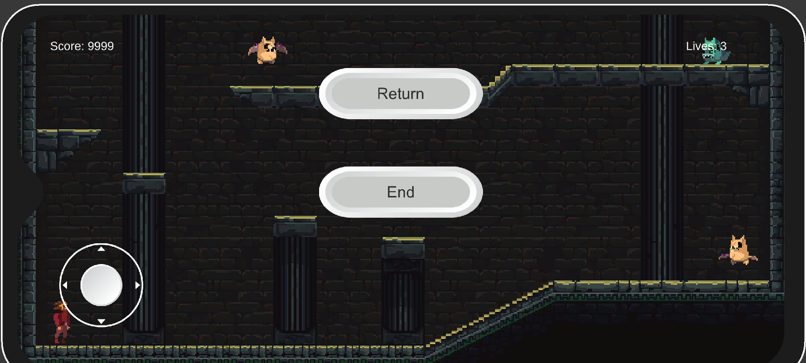 *The game interface will look something similar to this, except with a lot more detail, and some things gone, such as the play scene text, and the buttons.*

1. **Menu and Screen Descriptions**

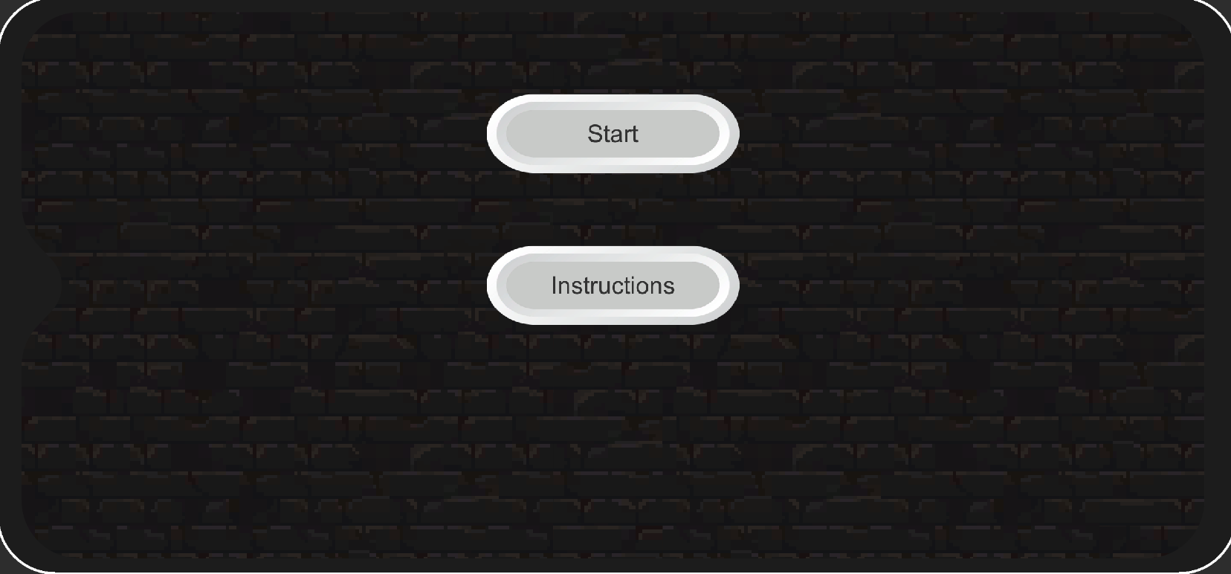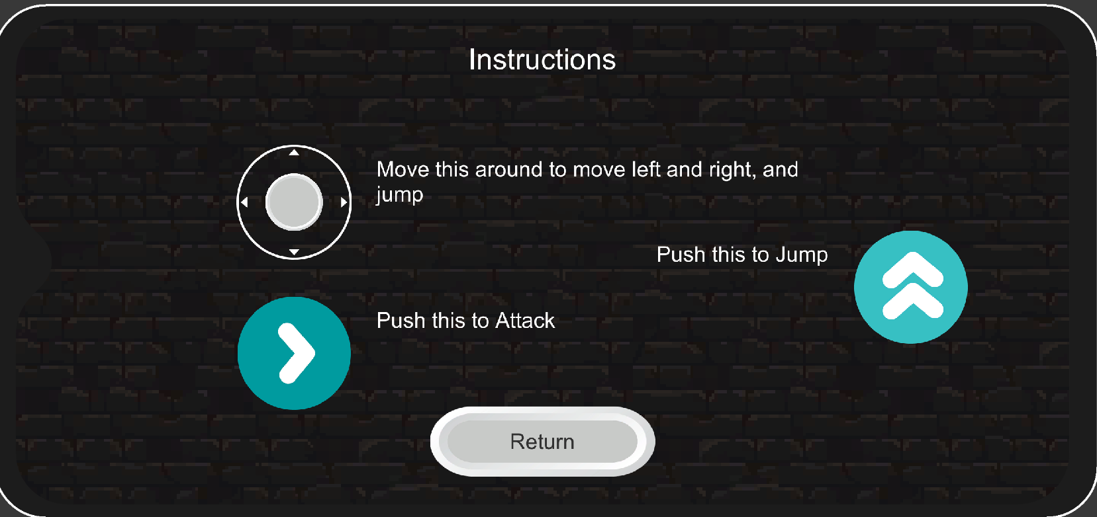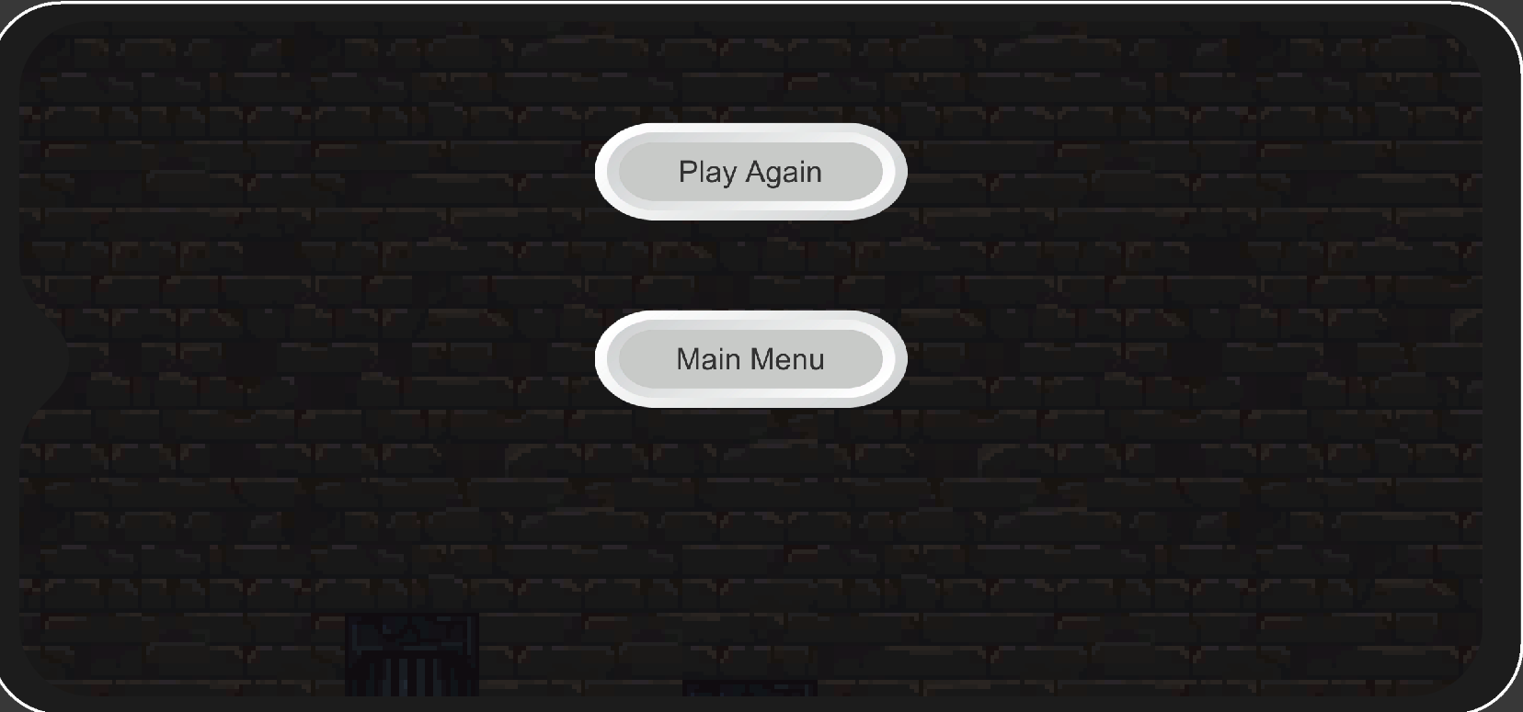

*Some other Menu screens include the main menu screen, instructions, and a game over scene.*

1. **Game World**

*An explorer exploring abandoned Dungeons looking for treasures*

1. **Levels**

*At the moment there is only 1 level, but more are planned to be added with increased difficulty, and even boss levels.*

1. **Characters**

*An Adventurer, equipped with a sword and his ambitions*

1. **Non-player Characters**

*At the moment there are no non player character allies that are in the game.*

1. **Enemies**

*There are a range of enemies for the player to encounter, bats, rat creatures, carnivorous plants, snake things, and more. Each will have a good amount of ai to them that will make them all seem unique.*

1. **Weapons**

*The only weapon available is a sword at the moment, which is used to destroy enemies.*

1. **Items**

*There are no in game items that can aid or hinder the player at the moment, items such as upgraded weapons or armor, and even powers are planned.*

1. **Cheat Codes**

*(None at the moment maybe later for score adding, and lives adding)*

1. **Sound Index**

* *BossBattle1*
* *BossBattle2*
* *DamageSound*
* *EnemyHit*
* *EnemySnarl*
* *Jump*
* *PowerUp*
* *Smash*
* *StrongEnemy*
* *UndergroundAmbient*
* *Walking1*
* *Walking2*
* *Walking3*
* *WarningSound*

1. **Story Index**

*This game is about an adventurer who is looking for a new adventure when he gets warped into a never ending dungeon, and has to try to find a way out.*

1. **Art / Multimedia Index**

* **refer to the Screenshots provided.**

1. **Future Features**

*I hope to add more enemies and include multiple different level types. With powerups and such.*